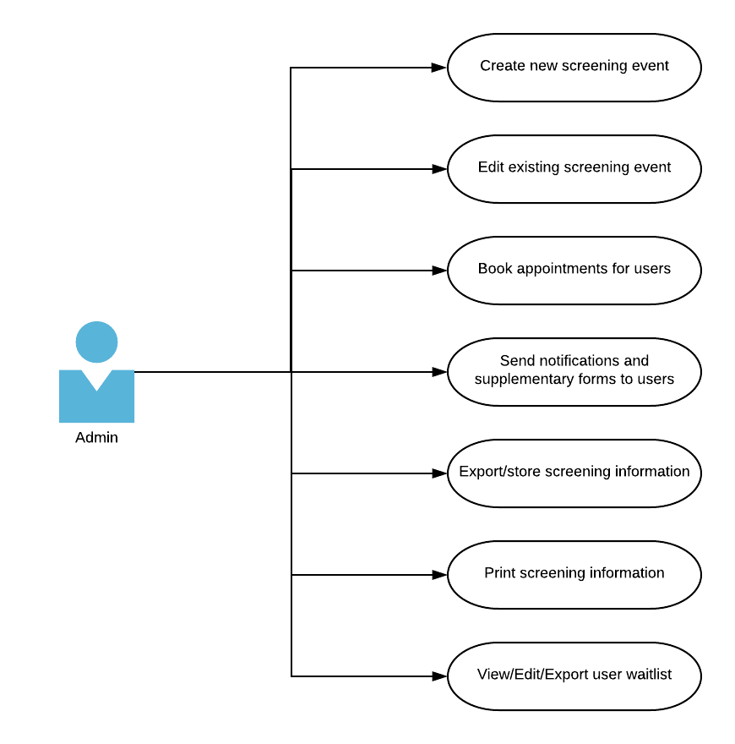

An Admin Use Case Diagram describes how an admin can use this system to create events, book appointments, and track information.